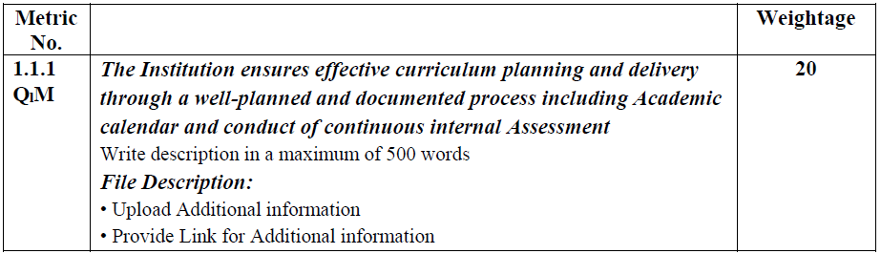

|  |  |  |
| --- | --- | --- |
| 1.1.1. |  |  |
| S.NO | NAME OF THE DOCUMENT | PAGE NO |
| 1 | University Academic Calendar Of 5 Years |  |
| 2 | Work Load Of Faculty Of Each Department |  |
| 3 | Vision & Mission Of Departments |  |
| 4 | CO'S AND PO'S AND PSO'S of Programs With Mapping |  |
| 5 | Lesson Plan Of One Course Of Each Program For The Latest Academic Year |  |
| 6 | Class Time Table (Latest Academic Year) |  |
| 7 | Department Academic Calendar ( Latest Academic Year) |  |
| 8 | Syllabus Coverage Report |  |
| 9 | Course File Content ( One Sample) |  |
| 10 | Gap Analysis |  |

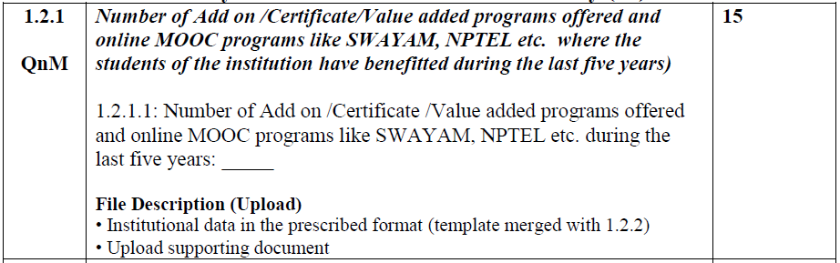

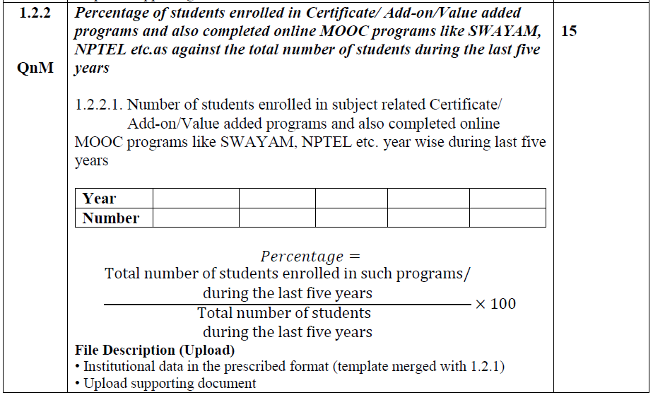

|  |  |  |  |  |  |  |  |  |
| --- | --- | --- | --- | --- | --- | --- | --- | --- |
| 1.2.1 |  |  |  |  |  |  |  |  |
|  | Add on courses as per template | } | **Year wise to be given** |
|  | Certificate courses as per template |
|  | Mooc courses as per template |
|  | Value added courses as per template |
|  |  |  |  |  |  |  |  |  |
|  |  |  |  |  |  |  |  |  |
|  | Additional Information  **Year 1** |  |  |  |  |  |  |  |
|  |  |  |  |  |  |  |  |  |
| **S. No** | **Name of the value added course** | **Semester** | **Date** | | **No. of Hours** | **No. of Students** | **Attendance Sheet Attached** |  |
|  |  |  | From | to |  |  |  |  |
|  |  |  |  |  |  |  |  |  |
|  |  |  |  |  |  |  |  |  |

a Circulars on Value added courses from HOD.

b Exam on Value Added courses and there results.

c Summary Report on Value added course.

d Certificates[Model Certificates] .

For 1.2.2

Supporting documents would be

1. Summary sheet with details percentage students completed the courses.
2. Sample Certificates which is already the part of 1.2.1

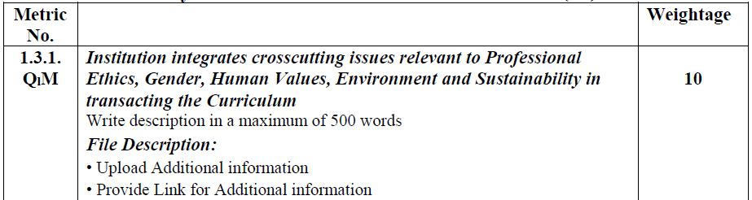

* Write up of 500 words
* Syllabus copies of all courses which are addressing professional ethics, gender, human values, environment sustainability.

|  |  |  |  |
| --- | --- | --- | --- |
| S.No | Name of the program | Course Name and Code | Unit no |
|  |  |  |  |
|  |  |  |  |

* Attach all the courses and highlight the content matching with above statements and also show the CO PO mapping Matrix of courses addressing the above issues.
* List of programs organized on gender

|  |  |  |  |  |
| --- | --- | --- | --- | --- |
| S. No | Name of the program | Date | Name of the expert | No. of Students |
|  |  |  |  |  |

Similarly programs organized on environment and sustainability to be attached

List of faculty who have certified in human values and certificate to be attached.

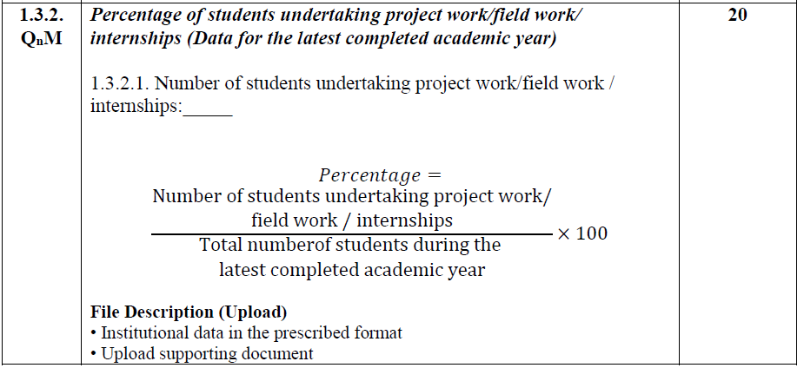

* Fill the table as per format
* Project work (2022-2023)

Data to be attached

|  |  |  |  |  |  |  |  |
| --- | --- | --- | --- | --- | --- | --- | --- |
| S.No | Name of the Program | Semester | Fieldwork/ Project Work/ Internship | Name of the Company | Date | | Certificate |
|  |  |  |  |  | From | to |  |
|  |  |  |  |  |  |  |  |
|  |  |  |  |  |  |  |  |

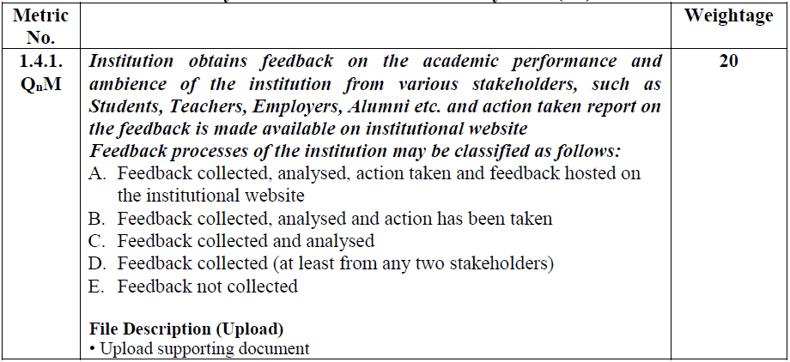

* Feedback On Faculty By Students
* Feedback On Infrastructure By Students
* Feedback On Infrastructure By Parents
* Feedback On Course By Students
* Feedback On Course By Faculty
* Feedback On Program Curriculum By Students
* Feedback On Program Curriculum By Faculty
* Feedback On Program Curriculum By Employer
* Feedback On Program Curriculum By Alumni
* Action Taken Reports Year Wise